Welcome!
Date
Name
Spouse
Address
City
State Zip _________
Email

Please Contact By
❑ Card  Phone  Visit

Telephone Best Time to Call
Home ______________
Work ______________

Guest: First Time Second Time
Are you a church member: yes no
Church
City, State

Circle Appropriate Age/Grade Group(s)
Preschool: Ages: B-1 2-3 4-5
Children: Grades: K 1 2 3 4 5 6
Youth: Grades: 7 8 9 10 11 12
Adults: Ages:18-29 30s 40s 50s 60s+

How did you learn about our church?
Newspaper Friend Yellow Pages Mail
Other

I am a guest of:

New in the Community? Yes No
Names & ages of children at home

Weekly Service & Activity Schedule

Jan 21, 2018

9:45 a.m. Sunday School
11:00 a.m. Worship Service
6:00 p.m. Evening Service

Week of Jan 21, 2018
Wednesday 6:30 pm……………..……….Meal/Bible Study
Friday 6:30 pm……………….…………..Men’s 42 Night

February
4………………………………New Commandment Kids
11……………………………..New Commandment Kids
11………………………….………Valentine’s Luncheon
11……………………………………….Business Meeting
March
4 – 11…..Wk of Prayer for Annie Armstrong Missions



Valentine’s Day Potluck Lunch
Sunday Feb.11
After the worship service
Bring your favorite person and your favorite dish!
Come with hearts prepared

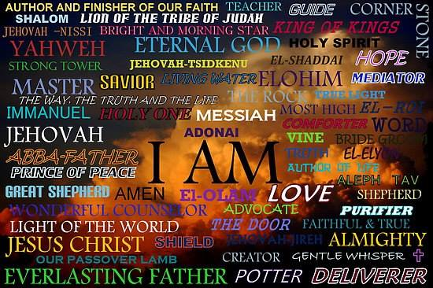

Knobbs Springs Baptist Church

Jan 21, 2018

Church Information:

KnobbsSpringsBC.com KnobbsSpringsBaptist@gmail.com

1662 CR 305, McDade, Texas 78650 512-273-2743

David Atwood, Pastor Cell 512-470-5098

Patti Radford, Office Manager Cell 512-968-7821

